An Analysis of Directorial Technique in Film Noir
- Through the Works of John Woo -

Yuanyuan Chen, Wonho Choi

Department of Visual Contents, Division of Digital Contents
Graduate School of Dongseo University, Dongseo University
Busan, South Korea
731015222@qq.com, choiwh@dongseo.ac.kr

Abstract

Film noir addresses topics such as violence, drugs, theft, kidnapping and murder to offer indirect experience to the audience. These characteristic elements of film noir are each dramatized through different directorial techniques. This paper systematizes the characteristics of those criminal elements in film noir and examines directorial techniques used to express them through the works of John Woo.

Keywords- Film noir; John Woo; Violence; Drugs; Theft

I. Introduction

Film noir was born out of the combination of traditional Hollywood style direction and narrative practices. Noir scenario reflects the historical backgrounds of the period depicted with influences from German expressionism, French poetic realism, and American gangster culture. Film noir is widely perceived to be an umbrella concept over action, crime and thriller films; it’s a highly successful genre with public interest [1].
Film noir by virtue of its subject matter tends to emphasize negative elements in the individual and in the society at large in an indirect manner; their resolution brings vicarious satisfaction. For an analysis of the public reception of film noir, a more detailed understanding of genre characteristics is called for, based on which the success of the genre can then be examined. Such understanding of the structural characteristics of film is necessary for understanding the directorial intentions of the director;it will also facilitate an understanding of supplementary devices used to express the genre.
This study begins with a literature review of researches of film noir in order to further categorize the genre and systematically review their characteristics. Based on this analysis, scenes from films will be examined for directorial techniques. For more detailed analys is of the genre of film noir and directorial techniques, the present study will focus on the works of a master of Hong Kong film noir, John Woo. The goal is to examine different directorial techniques for key elements of film noir, namely violence, drugs, theft, etc and systematize directorial techniques.

II. Film Noir: Definition and Characteristics

Film noir refers to a particular style of detective or crime films. Emphasising a moral outlook which blurs the distinction between good and evil as well as elements of self-satisfaction, film noir expresses images of dark world, pessimistic thinking and cynicism. These films show negative actions of criminals, social constraints, gloomy life and pessimistic sentiments to depict lives in negative sentiments and danger [2].
Film noir creates artistic elements through distinctive style and methods, particularly in visual effect, sound effect, scenes of violence, action, close-up scenes and editing, which characterize the unique aesthetics of film noir.

III. Film Noir: Criminal Elements

Film noir addresses negative subjects. Although there is no clear definition, it is widely understood as a concept which mainly covers violence, drugs, theft and thriller. Violence, drugs and theft are kinds of crime, while thriller uses horror as main subject [3]. The present study analyses films whose main subjects are crimes like violence, drugs and theft.

A.Violence

The dictionary definition of violence is “physical force exerted through illegal means such as attack on person.” However, in common parlance, violence includes physical harm as well as psychological damage. Violence in film provides indirect experience and catharsis to the audience. While the audience sometimes feels displeasure at violence, such indirect violence also brings psychological relief. Sometimes unrealistic violence is expressed to raise alarm about violence.

B. Drugs

Drugs in films are used as a means of emphasizing the negative aspects of criminal organizations. Those who use drugs are seen as weak, negative presence in society; sometimes it is portrayed as a means of escapism. However, more fundamentally, drugs are presented as something to be rejected. The idea is to make the audience more vigilant and alarmed about drugs.

C. Theft

Also called caper movies or heist movies, these are films about stealing something. Novel ways of stealing are shown to create a dramatic impact on the audience. Frequent subjects include bank, works of art and important documents; the audience can indirectly experience those inaccessible worlds through theft in films.
Most of crimes in films are negative elements in real life. However, films highlight or emphasize them to create cinematic situations.
The abovementioned elements are common subjects in film nor. The present study seeks to examine directorial techniques used for each one of them so as to systemize types of direction. Thus the next step is to analyse John Woo’s films which depict violence, drugs and theft. John Woo is widely known as the godfather or the legend of Hong Kong film noir; he made Hong Kong film noir known on the global stage. Hence an analysis of John Woo’s works will also provide an indirect insight into the development of the film noir genre.

IV. Characteristics of Directorial Techniques by Subject

A. Violence (A Better Tomorrow, 1987)

< A Better Tomorrow> is John Woo’s early work and one of his best-known works; it marks an important milestone in the history of Hong Kong film noir. The film follows the story of long despair and revenge. < A Better Tomorrow> addresses the anxiety of Hong Kong people after a decision was taken to return Hong Kong to China through the elements of violence. Swords in martial arts films of the past were replaced with guns; it is thus dubbed modern martial arts film, depicting gloomy images.
As in Fig. 1, the film expresses the anxiety of the people in the historic period through the themes of betrayal and revenge. For this, slow-motion, jump cut and sentimental music are used in various parts of the film. The harmony of the images of violence and music still resonates to contemporary audience. The kind of slow motion scene where the hero was shot with a machine gun in <Bonnie And Clyde> was also used in a similar fashion in <A Better Tomorrow> [4]. When Mark Lee is hit with bullets, his body moves back and forth, blood spewing out of his body. Many scenes are obscure and yet elegant. Flashy shooting scenes, in contrast with the gloomy images of anxiety, betrayal and revenge, are further enhanced by stark contrast in lighting. Diagonal and vertical composition also effectively express the lethargy of the city.
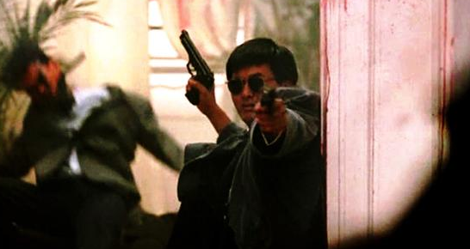
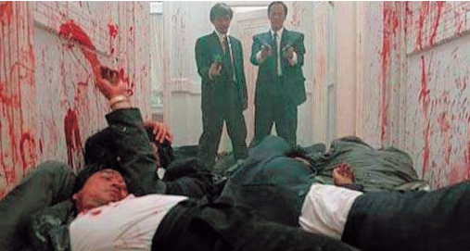
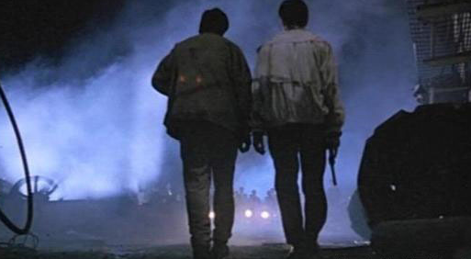

Fig. 1 Scenes of violence in <A Better Tomorrow>.

B. Drugs (Bullet In The Head,1997)

This film expresses the meaning of imperialism in the history of Hong Kong, inhumanity of war, the anxious psychology and nostalgia of Hong Kong residents who will assume a new nationality in time. The weakness of humanity is emphasized amid war and violence.
John Woo boldly extended the story to Vietnam and expanded the scope of the film. From the story of betrayal and revenge to brotherly love, accidentally caused schism, murder for profit and final revenge, the film depicts the world of men and social reality. As in Fig.2, the film uses drugs as an element which represents the anxiety of characters. While violence and war are main motifs of the film, drugs are also used as a supplementary device which expresses the anxiety and weakness of people trapped in the situation. Characters and scenes show explosive actions, and contrast is made with metaphors about fate. <Bullet in the Head> includes delicate visuals and flashbacks, at times feeling almost poetic. These soft elements form a stark contrast with the elements of chaotic reality such as unstable politics, war and prisoner of war camp. Scenes of contrast amplify confusion about drugs. Such changes in the film create an impression as if two films are merged into one, mixing dynamism with serenity.
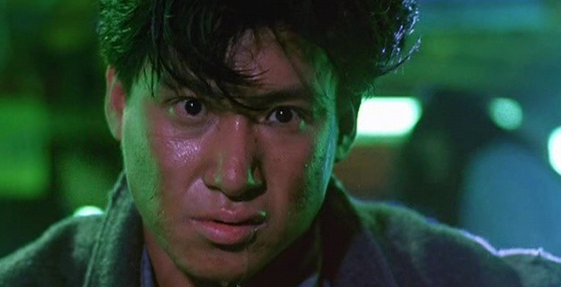
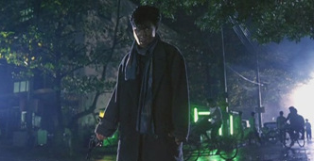
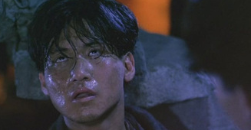

Fig. 2 Scenes of drug in <Bullet in the Head>.

C. Theft (Once A Thief ,1991)
Three heroes are professional thieves who steal works of art and antiques. While stealing an expensive work of art for commission, they are attacked. One of the three thieves die as a result; when it is told that his master and client were behind the killing, a story of revenge unfolds.
As shown in Fig. 3, theft in the film is not necessarily of gloomy nature. The heroes became thieves by the forces of the time, but negative elements are overcome with a cheerful tone. To this end, against dark backdrop, characters are brightly lighted; comic elements in the act of theft depict characters as such.
Film noir uses character, background, lighting and composition to express violence, drugs and theft. The element of violence is usually expressed through action, whereas drugs and theft use character, makeup and lighting. All three elements find emotional expressions around characters,lighting in particular emphasizes the emotional state of characters [5].

V. Conclusion

This study examines the characteristics and directorial techniques of film noir, a genre perceived as covering many negative elements. Of many expressions of different kinds of criminal elements in film noir, the present study addressed the cinematic characteristics of violence, drugs and theft through the works of John Woo. The analysis shows that each element is used to represent the social situation or maximize the depiction of emotions. To that end, changes in composition, camera works and lighting were used to highlight the director’s intentions.
While the present study may be one of factual analysis, examining the works of the highly successful film noir director John Woo presents a way of systematizing the directorial characteristics of film noir. A comparison of contemporary film noir productions will also present an insight into the changes in directorial methods.
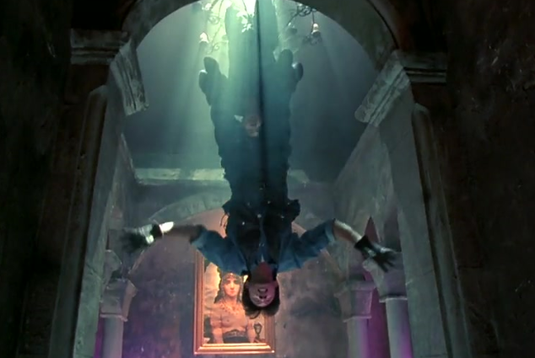
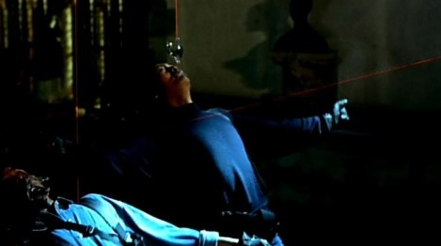
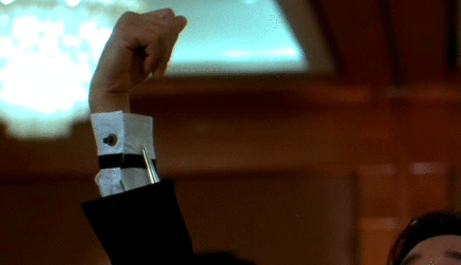

Fig. 3 Scenes of Theft in <once a Thief>.
References

- W. Kim, “Birth of early Korean film noir : Through a comparison of <Night Before Independence>(Inkyu Choi, 1948) and <Fate’s Hand>(Hyungmo Han, 1954),” Master’s Thesis, Hongik University, 2015.
- Pieter, "Entertainment Terror: The Postmodern Elements of Contemporary Horror Films," World Cinema, Vol. 3, pp.36, 1998.
- X. Wang, Violent Movies: Expression and Meaning, China Communication University Press, pp.12, 2007.
- P. David, and J. He, The Secret of Hong Kong Movies, Hainan Publishing House, pp.276, 2003.
- Y. Ma, and H. Zhang, "Action: a kind of strength, one kind of sentiment -- the famous Chinese movie director Johnwoo talks about the movie and the dream," Beijing Film Journal, pp.80, 2005.

